A FIELD PROJECT REPORT ON

**PET ADOPTION PLATFORM**

Submitted in partial fulfilment of the requirements for the award of the degree

**BACHELOR OF TECHNOLOGY**

in

**COMPUTER SCIENCE AND ENGINEERING**

Submitted by

|  |  |
| --- | --- |
| T. Venkat Rami Reddy | (231FA04462) |
| D. Akshaya Reddy | (231FA04613) |
| Prithi Prabha | (231FA04F77) |
| P. Manikanta Saketh | (231FA04F81) |
|  |  |



Department of Computer science and Engineering

School of Bachelor of Technology

Vignan’s Foundation for Science, Technology and Research (Deemed to be University) Vadlamudi, Guntur, Andhra Pradesh-522213, India

**April – 2025**



**CERTIFICATE**

This is to certify that the field project entitled “ **PET ADOPTION PLATFORM** ” being submitted by (T. Venkat Rami Reddy & 231FA04462), (D. Akshaya Reddy & 231FA04613), (Prithi Prabha & 231FA04F77), and (P. Manikanta Saketh & 231FA04F81) in partial fulfilment of Bachelor of Technology in the Department of Computer science and Engineering, Vignan’s Foundation For Science Technology & Research (Deemed to be University), Vadlamudi, Guntur District, Andhra Pradesh, India, is a bonafide work carried out by them under my guidance and supervision.

|  |  |
| --- | --- |
| **Head of the Department** | **Guide** |

**DECLARATION**

We hereby declare that our project work described in the field project titled “**PET ADOPTION PLATFORM**” which is being submitted by us for the partial fulfilment in the department of Computer science and Engineering, Vignan’s Foundation for Science, Technology and Research (Deemed to be University), Vadlamudi, Guntur, Andhra Pradesh, and the result of investigations are carried out by us under the guidance of (**Mr.Ch.Amaresh**)

|  |  |  |
| --- | --- | --- |
| T. Venkat Rami Reddy | (231FA04462) | Signature |
| D. Akshaya Reddy | (231FA04613) | Signature |
| Prithi Prabha | (231FA04F77) | Signature |
| P. Manikanta Saketh | (231FA04F81) | Signature |

**Table of Contents**

|  |  |  |  |
| --- | --- | --- | --- |
|  |  | **Contents** | **Page No** |
| 1 |  | Introduction | 5-6 |
|  | 1.1 | Problem Definition | 5 |
|  | 1.2 | Existing System | 5 |
|  | 1.3 | Proposed System | 6 |
|  | 1.4 | Literature Review | 6 |
| 2 |  | System Requirements | 7-8 |
|  | 2.1 | Hardware &Software Requirements | 7 |
|  | 2.2 | Software Requirements Specifications(SRS) | 8 |
| 3 |  | System Design | 9-11 |
|  | 3.1 | Modules of System | 9-10 |
|  | 3.2 | UML Diagrams | 10-11 |
| 4 |  | Implementation | 12-60 |
|  | 4.1 | Sample code | 12-60 |
|  | 4.2 | Test Cases | 60 |
| 5 |  | Results | 61-65 |
|  | 5.1 | Output Screens | 61-65 |
| 6 |  | Conclusion | 66 |
|  |  | References | 66 |
|  |  | Git-Hub link | 66 |

1. **INTRODUCTION:**

Our project focuses on creating a pet adoption platform dedicated to the **rescue and rehabilitation of street animals**. Unlike traditional adoption services, this platform is designed not for profit, but as a **community-driven initiative** to ensure that **homeless and often vulnerable street pets are given a second chance at life**.The platform aims to act as a **bridge between rescued street animals and compassionate adopters**, while working closely with **local shelters and social welfare organizations**. These collaborations will help ensure that all animals are **properly vaccinated, given medical care**, and **assessed for behavior and safety** before being made available for adoption.

Through features such as **real-time pet listings, vaccination and health tracking, and adoption guidelines**, we aim to promote **responsible pet ownership** and **reduce the number of animals living in unsafe street environments**. By offering this service free of charge, we hope to encourage more people to adopt, not shop, and **contribute to a more humane society** where every pet has a safe, loving home.

1. **PROBLEM DEFINTION:**

Street animals often face neglect, abuse, and lack of medical care, leading to safety concerns for both the animals and the communities they live in. Many of these animals go unnoticed and unprotected due to the absence of a structured system for their rescue, rehabilitation, and adoption. Additionally, the lack of coordination between rescue groups, shelters, and the public hinders efforts to provide long-term solutions.

Our platform addresses these challenges by offering a **centralized, user-friendly, and non-commercial system** that focuses on **rescuing street pets**, providing them with **proper shelter, vaccination, and care** through partnerships with **social welfare organizations**, and then responsibly placing them into loving homes. By using digital tools to increase visibility, track medical history, and manage adoptions, the platform helps ensure **safe, ethical, and sustainable pet placements**, while promoting **community participation and compassion towards street animals**.

**1.2 EXISTING SYSTEM:**

* **Physical Animal Shelters & Rescue Centres:**  
  Limited in capacity and often overburdened, making it difficult to accommodate the growing number of street animals.
* **Social Media-Based Adoption Drives:**  
  Lacks structure, verification, and long-term tracking of adopted animals, which may lead to irresponsible adoptions.
* **Commercial Online Pet Adoption Platforms (e.g., Petfinder, Adopt-a-Pet):**  
  Primarily focused on breed-specific or owned pets; minimal focus on street animals or medical vetting, and often lack collaboration with local NGOs.

1. **PROPOSED SYSTEM:**

The proposed platform is a **non-commercial, socially-driven solution** designed to rescue, rehabilitate, and rehome **street animals** through an **organized and transparent digital system**. It addresses key limitations of existing systems by incorporating the following features:User-Friendly Online Platform

* ****Dedicated Platform for Street Pets:****A centralized space to register, display, and manage adoptable street animals rescued by individuals or NGOs.
* ****Shelter & Safety First Approach:****Ensures rescued animals are **temporarily sheltered**, **vaccinated**, and **assessed for behavior** before adoption, in collaboration with social and veterinary organizations.
* ****Adoption as a Service, Not a Business:****The platform runs on **volunteer and NGO participation**, promoting adoption **without any commercial transactions**.
* ****Post-Adoption Support & Monitoring:****Tracks the wellbeing of adopted pets, offering post-adoption support and regular health check updates through connected services.

1. **LITERATURE REVIEW:**

The literature highlights that although existing online pet adoption platforms have made pet adoption more accessible, they largely cater to owned or shelter pets and rarely address the unique challenges associated with **street animal rehabilitation and adoption**. Common issues such as **lack of medical records, limited post-adoption tracking, and minimal coordination with social welfare groups** hinder the safe adoption of street pets.

Furthermore, these platforms often operate commercially, leaving out communities who wish to **adopt out of compassion rather than commerce**. Studies suggest that integrating **community partnerships**, **healthcare collaborations**, and **technology-driven tracking systems** can significantly improve outcomes for rescued street animals. Our project builds upon this gap by proposing a **non-profit, shelter-focused platform** that leverages **digital tools** to ensure each rescued street pet receives **proper care, vaccination, and a safe home**, supported by **post-adoption follow-ups and NGO collaboration**.

1. **SYSTEM REQUIREMENTS**

**2.1 Hardware & Software Requirements:**

**Hardware Requirements:**

**In our pet adoption webpage**, the **hardware requirements** section in our project document should include the **minimum and recommended** system specifications needed to run the project smoothly. Here’s what you can include:

### ****Hardware Requirements for Pet Adoption Webpage****

#### ****1. Server Requirements (If Hosted Locally)****

* **Processor**: Intel Core i5 (or equivalent)
* **RAM**: 8GB (minimum), 16GB (recommended)
* **Storage**: 50GB SSD (for database & website files)
* **Internet**: High-speed broadband connection
* **Operating System**: Windows 10/11, Linux (Ubuntu), or macOS

#### ****2. Client (User) Requirements****

* **Device**: PC, Laptop, Tablet, or Smartphone
* **Processor**: Any modern CPU (Intel/AMD, Apple M-series)
* **RAM**: 4GB (minimum), 8GB (recommended)
* **Storage**: 500MB (for browser cache & saved data)
* **Internet**: WiFi or mobile data (minimum 2 Mbps speed)
* **Browser**: Chrome, Firefox, Edge, Safari (latest versions)

#### ****3. Hosting & Database Server (If Using Cloud)****

* **Hosting Provider**: GitHub
* **Database Server**: MongoDB compass(Local) and MySQL (Xampp)
* **Storage Space**: At least 5GB for images & user data
* **Server Uptime**: 99.9% (recommended for better performance)

**Software Requirements:**

The development and deployment of the **Pet Adoption Webpage** require various software tools and technologies. Below are the software components used:

**1. Frontend Development:**

* **HTML (HyperText Markup Language)** → Used to structure the webpage content.
* **CSS (Cascading Style Sheets)** → Used for styling and layout design.
* **JavaScript (JS)** → Used for dynamic interactions and client-side validations.

### ****2. Backend Development:****

* **Node.js** → JavaScript runtime environment for handling server-side logic.
* **Express.js** → A lightweight framework for building APIs and handling requests.

### ****3. Database Management:****

* **MongoDB Compass** → GUI tool for managing and querying MongoDB databases.

### ****4. Alternative Backend & Database (For Testing):****

* **XAMPP (Apache, MySQL, PHP, Perl)** → Local server setup for running PHP-based applications.
* **PHP** → Alternative backend scripting language for handling form submissions and data storage.
* **MySQL** → Alternative database used in XAMPP for structured data storage.

### ****5. Development & Testing Tools:****

* **Visual Studio Code (VS Code)** → Used as the primary code editor.
* **Web Browsers (Chrome, Firefox, Edge)** → Used for testing the webpage on different platforms.

1. **SYSTEM DESIGN:**

The system is designed to provide a **non-commercial, tech-enabled platform** for the **rescue, care, and adoption of street animals**. The platform ensures that every rescued pet receives proper shelter, vaccination, and care before being listed for adoption. It also connects adopters with necessary post-adoption resources like care tips and support contacts.

The system architecture follows a **modular design** to ensure easy maintenance, future scalability, and a smooth user experience.

**3.1 MODULES OF SYSTEM:**

**1. User Authentication Module**

* **Files:** login.html, login.php
* **Function:** Allows users (adopters or admins) to log in securely. Future expansion may support roles such as rescuers, NGOs, or volunteers.

**2. Pet Information Display Module**

* **Files:** index1.html, detail.html, page.html, image files (cat.jpg, dog.jpg, etc.)
* **Function:** Displays rescued pets (street animals) available for adoption with detailed information like name, age, species, and photos.

**3. Adoption Inquiry Module**

* **Files:** Likely handled in forms within the HTML pages (detail.html, page.html)
* **Function:** Enables users to show interest in a pet. May include forms for submitting adoption requests (can be integrated with backend PHP).

**4. Post-Adoption Care Tips Module**

* **Folder:** care tips
* **Function:** Educates adopters on pet care, ensuring smooth adjustment and responsible ownership.

**5. Contact & Social Collaboration Module**

* **Folder & Files:** Contact/, Contact.zip
* **Function:** Contains contact forms and information to connect with NGOs, shelters, or support teams for vaccination and follow-up.

**6. Adoption Processing & Admin Module**

* **Folder:** process/
* **Function:** Intended for handling internal processing of adoption requests, admin review, or record maintenance.

**7. Frontend Interface & User Experience Module**

* **Files:** style.css, script.js
* **Function:** Provides styling and interactivity for the platform, ensuring a user-friendly experience.

1. **UML Diagrams**

**USE-CASE**

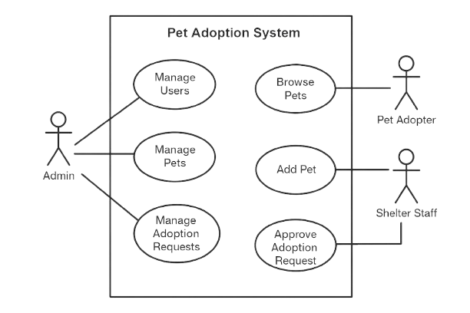

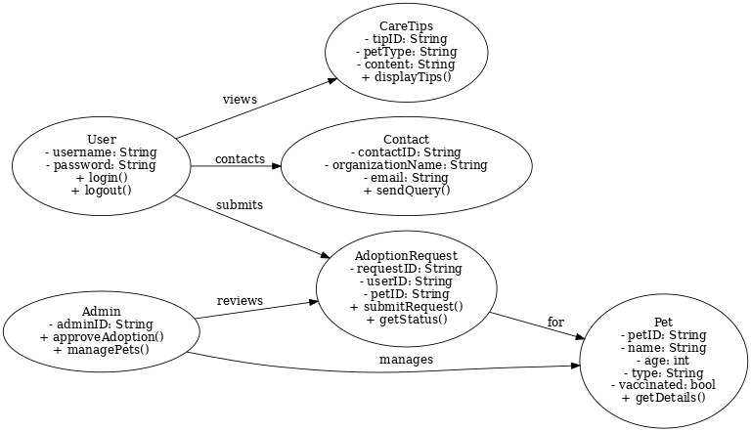

**CLASS-DIAGRAM**

**UML Sequence Diagram**

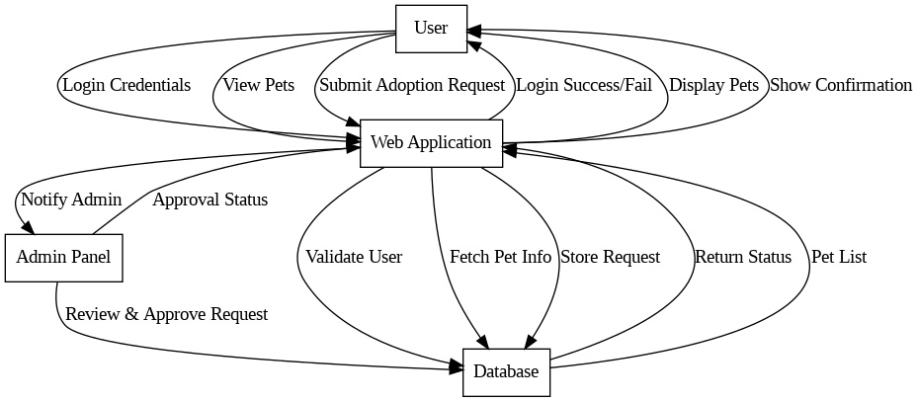

1. **IMPLEMENTAION:**

The implementation phase involves developing and integrating the system's frontend, backend, database, and APIs.

* + - * 1. **SAMPLE CODE:**

**HOMEPAGE(HTML):**

<!DOCTYPE html>

<html lang="en">

<head>

<meta charset="UTF-8">

<meta name="viewport" content="width=device-width, initial-scale=1.0">

<title>Pet Adoption Homepage</title>

<link href="https://fonts.googleapis.com/css2?family=Poppins:wght@400;500;600;700&display=swap" rel="stylesheet">

<linkrel="stylesheet"href="https://cdnjs.cloudflare.com/ajax/libs/fontawesome/6.7.2/css/all.min.css"integrity="sha512Evv84Mr4kqVGRNSgIGL/F/aIDqQb7xQ2vcrdIwxfjThSH8CSR7PBEakCr51Ck+w+/U6swU2Im1vVX0SVk9ABhg=="crossorigin="anonymous"referrerpolicy="no-referrer" />

<linkrel="stylesheet"href="https://cdn.jsdelivr.net/npm/swiper@11/swiperbundle.min.css">

<link rel="stylesheet" href="style.css" />

</head>

<body>

<!-- Header -->

<header>

<div class="container">

<div class="logo">adopt-a-pet</div>

<nav>

<ul>

<li><a href="#">Home</a></li>

<li><a href="search/index.html">Find Pet</a></li>

<li><a href="process/index.html">Adoption Guidelines</a></li>

<li><a href="care tips/index.html">Pet Care Tips</a></li>

<li><a href="Contact/index.html">Contact</a></li>

</ul>

</nav>

<button class="cta-button">Adopt Now</button>

<a href="login.html" class="login-button">Login</a>

</div>

</header>

<!-- Hero Slider -->

<div class="swiper mySwiper">

<div class="swiper-wrapper">

<div class="swiper-slide" style="background-image: linear-gradient(rgba(0, 0, 0, 0.5), rgba(0, 0, 0, 0.5)), url('dog.jpg')">

<div class="container">

<div class="hero-content">

<h1 class="animated fadeInDown">Find Your Perfect Pet</h1>

<p class="animated fadeInUp">Give a loving home to a furry friend</p>

<div class="buttons animated fadeInUp">

<a href="search/index.html" class="primary-button">Find Pet</a>

<a href="care tips/index.html" class="secondary-button">Adoption Guide</a>

</div>

</div>

</div>

</div>

<div class="swiper-slide" style="background-image: linear-gradient(rgba(0, 0, 0, 0.5), rgba(0, 0, 0, 0.5)), url('cathomme.jpg')">

<div class="container">

<div class="hero-content">

<h1 class="animated fadeInDown">Save a Life Today</h1>

<p class="animated fadeInUp">Every pet deserves a second chance</p>

<div class="buttons animated fadeInUp">

<a href="/success-stories" class="primary-button">Success Stories</a>

<a href="/donate" class="secondary-button">Support Us</a>

</div>

</div>

</div>

</div>

<div class="swiper-slide" style="background-image: linear-gradient(rgba(0, 0, 0, 0.5), rgba(0, 0, 0, 0.5)), url('tri.jpg')">

<div class="container">

<div class="hero-content">

<h1 class="animated fadeInDown">Save a Life Today</h1>

<p class="animated fadeInUp">Every pet deserves a second chance</p>

<div class="buttons animated fadeInUp">

<a href="/success-stories" class="primary-button">Success Stories</a>

<a href="/donate" class="secondary-button">Support Us</a>

</div>

</div>

</div>

</div>

</div>

<div class="swiper-pagination"></div>

<div class="swiper-button-next"></div>

<div class="swiper-button-prev"></div>

</div>

<!-- Featured Pets Section -->

<section class="featured-pets">

<div class="container">

<h2>Meet Our Furry Friends 🐾</h2>

<div class="pet-grid">

<div class="pet-card">

<img src="dog2.jpg" alt="Dog">

<h3>Max</h3>

<p>Golden Retriever | 2 years old</p>

<button>View Details</button>

</div>

<div class="pet-card">

<img src="cat3.jpg" alt="Cat">

<h3>Luna</h3>

<p>Siamese | 1 year old</p>

<button>View Details</button>

</div>

<div class="pet-card">

<img src="dog3.jpeg" alt="Dog">

<h3>Buddy</h3>

<p>Beagle | 3 years old</p>

<button>View Details</button>

</div>

</div>

</section>

<!-- Key Features Section -->

<section class="key-features">

<div class="container">

<h2>Why Adopt With Us?</h2>

<div class="features-grid">

<div class="feature">

<span>❤️</span>

<h3>Healthy Pets</h3>

<p>All pets are vet-checked and vaccinated.</p>

</div>

<div class="feature">

<span>📋</span>

<h3>Easy Process</h3>

<p>Simple adoption steps.</p>

</div>

<div class="feature">

<span>🎓</span>

<h3>Lifetime Support</h3>

<p>Guidance for pet care and training.</p>

</div>

<div class="feature">

<span>🏠</span>

<h3>Happy Homes</h3>

<p>10,000+ pets adopted and counting!</p>

</div>

</div>

</div>

</section>

<section id="why-street-dogs" class="key-features">

<div class="container">

<h2>Why Adopt Street Dogs? 🐾</h2>

<div class="features-grid">

<div class="feature">

<span>💪</span>

<h3>Strong Immunity</h3>

<p>Street dogs often have natural resistance to many diseases</p>

</div>

<div class="feature">

<span>❤️</span>

<h3>Unconditional Love</h3>

<p>They show immense gratitude and loyalty to their adopters</p>

</div>

<div class="feature">

<span>🌍</span>

<h3>Save a Life</h3>

<p>Give a deserving street dog a chance at a better life</p>

</div>

</div>

</div>

</section>

<!-- Footer -->

<footer>

<div class="container">

<div class="mission">

<h3>Our Mission</h3>

<p>Responsible Adopt-pet: Ensuring that pets are placed in loving, suitable homes.</p>

<p>Safer Adoptions: Verifying adopters and educating them about responsible pet care.</p>

<p>Pet Welfare First: Partnering with animal shelters, NGOs, and volunteers to ensure the best care for pets.</p>

<p>Community-Driven Approach: Encouraging pet lovers to support and guide new adopters.</p>

</div>

<div class="footer-links">

<h3>Quick Links</h3>

<ul>

<li><a href="/">Home</a></li>

<li><a href="search/index.html">Find Pet</a></li>

<li><a href="/process/index.html">Adoption Guidelines</a></li>

<li><a href="Contact/index.html">Contact</a></li>

<li> </li>

</ul>

</div>

<div class="newsletter">

<h3>Join Our Newsletter</h3>

<input type="email" placeholder="Enter your email">

<button>Subscribe</button>

</div>

<div class="social-media">

<h3>Follow Us</h3>

<i class="fa-brands fa-facebook"></i>

<a href="https://www.instagram.com/pritiprabha\_\_\_" target="\_blank"><i class="fa-brands fa-instagram"></i></a>

<i class="fa-brands fa-twitter"></i>

<i class="fa-brands fa-youtube"></i>

</div>

<!-- <div class="location">

<h1>Embed Location Map</h1>

<iframe src="https://www.google.com/maps/embed?pb=!1m18!1m12!1m3!1d31126.453476398397!2d80.54432495223627!3d16.241139716207222!2m3!1f0!2f0!3f0!3m2!1i1024!2i768!4f13.1!3m3!1m2!1s0x3a4a09009cab727f%3A0x4d1622fac97b15c2!2sVignan%20Online!5e0!3m2!1sen!2sin!4v1742225852222!5m2!1sen!2sin" width="600" height="450" style="border:0;" allowfullscreen="" loading="lazy" referrerpolicy="no-referrer-when-downgrade"></iframe>

</div> -->

</div>

</footer>

<script src="https://cdn.jsdelivr.net/npm/swiper@11/swiper-bundle.min.js"></script>

<script src="script.js"></script>

</body>

</html>

**CSS FOR STYLING(HOME-PAGE)**

body {

font-family: Arial, sans-serif;

margin: 0;

padding: 0;

background-color: #f4f4f4;

}

.contact-header {

background-color: #5cb85c;

color: white;

text-align: center;

padding: 50px 20px;

font-size: 24px;

}

.contact-container {

max-width: 800px;

margin: 20px auto;

background: white;

padding: 20px;

border-radius: 10px;

box-shadow: 0 0 10px rgba(0, 0, 0, 0.1);

text-align: center;

}

.contact-info {

margin-bottom: 20px;

}

.contact-form {

display: flex;

flex-direction: column;

gap: 10px;

}

.contact-form input, .contact-form textarea {

width: 100%;

padding: 10px;

border: 1px solid #ccc;

border-radius: 5px;

}

.contact-form textarea {

height: 100px;

}

.contact-form button {

background-color: #5cb85c;

color: white;

border: none;

padding: 10px;

cursor: pointer;

font-size: 16px;

border-radius: 5px;

}

.contact-form button:hover {

background-color: #4cae4c;

}

.social-links {

margin-top: 20px;

}

.social-icon {

display: inline-block;

margin: 5px;

text-decoration: none;

font-size: 18px;

color: #5cb85c;

}

**SCRIPT(HOME-PAGE)**

document.addEventListener("DOMContentLoaded", function () {

// Swiper Initialization

const swiper = new Swiper(".mySwiper", {

slidesPerView: 1,

spaceBetween: 0,

loop: true,

effect: "fade",

fadeEffect: { crossFade: true },

autoplay: { delay: 5000, disableOnInteraction: false },

pagination: { el: ".swiper-pagination", clickable: true },

navigation: { nextEl: ".swiper-button-next", prevEl: ".swiper-button-prev" },

on: {

init: function () {

animateHeroContent(this.slides[this.activeIndex]);

},

slideChange: function () {

animateHeroContent(this.slides[this.activeIndex]);

},

},

});

function animateHeroContent(slide) {

const title = slide.querySelector("h1");

const description = slide.querySelector("p");

const buttons = slide.querySelector(".buttons");

if (title && description && buttons) {

title.classList.remove("fadeInDown");

description.classList.remove("fadeInUp");

buttons.classList.remove("fadeInUp");

// Trigger reflow

void title.offsetWidth;

void description.offsetWidth;

void buttons.offsetWidth;

title.classList.add("fadeInDown");

description.classList.add("fadeInUp");

buttons.classList.add("fadeInUp");

}

}

// Login & Logout Functionality

const userEmailDisplay = document.getElementById("user-email");

const loginBtn = document.getElementById("login-btn");

const logoutBtn = document.getElementById("logout-btn");

const adoptNowBtn = document.querySelector(".cta-button");

// Check stored login info

let userName = localStorage.getItem("loggedInUser") || localStorage.getItem("loggedInEmail") || localStorage.getItem("userEmail");

if (userName) {

let shortName = userName.includes("@") ? userName.split("@")[0] : userName; // Extract before '@' if email

userEmailDisplay.textContent = `Welcome, ${shortName}`;

userEmailDisplay.style.display = "inline-block";

loginBtn.style.display = "none";

logoutBtn.style.display = "inline-block";

// Move email display next to "Adopt Now" button

adoptNowBtn.insertAdjacentElement("afterend", userEmailDisplay);

} else {

userEmailDisplay.style.display = "none";

logoutBtn.style.display = "none";

loginBtn.style.display = "inline-block";

}

// Logout Functionality

logoutBtn.addEventListener("click", function () {

localStorage.removeItem("loggedInUser");

localStorage.removeItem("loggedInEmail");

localStorage.removeItem("userEmail");

window.location.href = "login.html"; // Redirect to login page

});

});

**LOG-IN(CREDENTIALS-RETREIVAL):**

<!DOCTYPE html>

<html lang="en">

<head>

<meta charset="UTF-8">

<meta name="viewport" content="width=device-width, initial-scale=1.0">

<title>Login - Pet Adoption</title>

<style>

\* {

margin: 0;

padding: 0;

box-sizing: border-box;

font-family: 'Poppins', sans-serif;

}

body {

display: flex;

justify-content: center;

align-items: center;

height: 100vh;

background: url('https://source.unsplash.com/1600x900/?cute-dog,adopt-pet') no-repeat center center/cover;

}

.container {

background: rgba(255, 255, 255, 0.9);

padding: 30px;

border-radius: 10px;

box-shadow: 0px 5px 15px rgba(0, 0, 0, 0.2);

text-align: center;

width: 350px;

transition: transform 0.3s ease-in-out;

}

.container:hover {

transform: scale(1.05);

}

h2 {

color: #FF9800;

margin-bottom: 20px;

}

input {

width: 100%;

padding: 10px;

margin: 10px 0;

border: 2px solid #ccc;

border-radius: 5px;

font-size: 16px;

transition: border-color 0.3s ease;

}

input:focus {

border-color: #FF9800;

outline: none;

}

input::placeholder {

color: #999;

transition: opacity 0.5s ease-in-out;

}

input:focus::placeholder {

animation: blink 1s infinite;

}

@keyframes blink {

0% { opacity: 1; }

50% { opacity: 0; }

100% { opacity: 1; }

}

button {

width: 100%;

padding: 10px;

background: #FF9800;

border: none;

color: white;

font-size: 16px;

border-radius: 5px;

cursor: pointer;

transition: background 0.3s ease, transform 0.2s;

}

button:hover {

background: #E65100;

transform: scale(1.05);

}

p {

margin-top: 15px;

font-size: 14px;

}

a {

color: #E65100;

text-decoration: none;

font-weight: bold;

}

a:hover {

text-decoration: underline;

}

</style>

</head>

<body>

<div class="container">

<h2>Login</h2>

<input type="email" id="email" placeholder="Email">

<input type="password" id="password" placeholder="Password">

<button onclick="login()">Login</button>

<p>Don't have an account? <a href="signup.html">Signup</a></p>

</div>

<script>

function login() {

const email = document.getElementById('email').value;

const password = document.getElementById('password').value;

if (!email || !password) {

alert("Please fill in all fields.");

return;

}

fetch('http://localhost:3000/login', {

method: 'POST',

headers: { 'Content-Type': 'application/json' },

body: JSON.stringify({ email, password })

})

.then(response => response.json())

.then(data => {

alert(data.message);

if (data.message === "Login successful!") {

const username = email.split('@')[0]; // Extracts only the username

localStorage.setItem("loggedInUser", username); // Store short username

window.location.href = "index1.html"; // Redirect to dashboard

}

})

.catch(error => alert("Error: " + error));

}

</script>

</body>

</html>

**SIGNUP(CREDENTIALS-STORAGE):**

<!DOCTYPE html>

<html lang="en">

<head>

<meta charset="UTF-8">

<meta name="viewport" content="width=device-width, initial-scale=1.0">

<title>Signup - Pet Adoption</title>

<style>

\* {

margin: 0;

padding: 0;

box-sizing: border-box;

font-family: 'Poppins', sans-serif;

}

body {

display: flex;

justify-content: center;

align-items: center;

height: 100vh;

background: url('https://source.unsplash.com/1600x900/?cute-dog,adopt-pet') no-repeat center center/cover;

}

.container {

background: rgba(255, 255, 255, 0.9);

padding: 30px;

border-radius: 10px;

box-shadow: 0px 5px 15px rgba(0, 0, 0, 0.2);

text-align: center;

width: 350px;

transition: transform 0.3s ease-in-out;

}

.container:hover {

transform: scale(1.05);

}

h2 {

color: #FF9800;

margin-bottom: 20px;

}

input {

width: 100%;

padding: 10px;

margin: 10px 0;

border: 2px solid #ccc;

border-radius: 5px;

font-size: 16px;

transition: border-color 0.3s ease;

}

input:focus {

border-color: #FF9800;

outline: none;

}

input::placeholder {

color: #999;

transition: opacity 0.5s ease-in-out;

}

input:focus::placeholder {

animation: blink 1s infinite;

}

@keyframes blink {

0% { opacity: 1; }

50% { opacity: 0; }

100% { opacity: 1; }

}

button {

width: 100%;

padding: 10px;

background: #FF9800;

border: none;

color: white;

font-size: 16px;

border-radius: 5px;

cursor: pointer;

transition: background 0.3s ease, transform 0.2s;

}

button:hover {

background: #E65100;

transform: scale(1.05);

}

p {

margin-top: 15px;

font-size: 14px;

}

a {

color: #E65100;

text-decoration: none;

font-weight: bold;

}

a:hover {

text-decoration: underline;

}

</style>

</head>

<body>

<div class="container">

<h2>Signup</h2>

<input type="text" id="username" placeholder="Username">

<input type="email" id="email" placeholder="Email">

<input type="password" id="password" placeholder="Password">

<button onclick="signup()">Signup</button>

<p>Already have an account? <a href="login.html">Login</a></p>

</div>

<script>

function signup() {

const username = document.getElementById('username').value.trim();

const email = document.getElementById('email').value.trim();

const password = document.getElementById('password').value.trim();

if (!username || !email || !password) {

alert("Please fill in all fields!");

return;

}

fetch('http://localhost:3000/signup', {

method: 'POST',

headers: { 'Content-Type': 'application/json' },

body: JSON.stringify({ username, email, password })

})

.then(response => response.json())

.then(data => {

alert(data.message);

if (data.success) {

localStorage.setItem('username', username);

localStorage.setItem('email', email);

window.location.href = "index1.html"; // Redirect to dashboard

}

})

.catch(error => alert("Error: " + error.message));

}

</script>

</body>

</html>

**Detals.html:**

<!DOCTYPE html>

<html lang="en">

<head>

<meta charset="UTF-8">

<meta name="viewport" content="width=device-width, initial-scale=1.0">

<title>Senior Dog Care</title>

<style>

body {

font-family: Arial, sans-serif;

margin: 40px;

background-color: #f9f9f9;

}

.header {

background: #ffcc66;

padding: 20px;

text-align: center;

font-size: 24px;

font-weight: bold;

position: relative;

}

.paw-print {

position: absolute;

left: 20px;

top: 10px;

font-size: 40px;

color: red;

}

.container {

display: flex;

gap: 20px;

justify-content: center;

margin-top: 20px;

}

.card {

background: white;

padding: 15px;

border-radius: 8px;

box-shadow: 0 4px 6px rgba(0,0,0,0.1);

width: 300px;

text-align: center;

}

.card img {

width: 100%;

border-radius: 8px;

}

.category {

color: gray;

font-size: 14px;

margin-top: 10px;

}

.title {

font-size: 20px;

font-weight: bold;

margin: 10px 0;

}

.description {

font-size: 14px;

color: #555;

}

.read-more {

display: inline-block;

margin-top: 15px;

padding: 10px 15px;

background: red;

color: white;

text-decoration: none;

border-radius: 5px;

}

.read-more-container {

text-align: center;

margin-top: 20px;

}

</style>

</head>

<body>

<div class="header">

<span class="paw-print">&#128062;</span>

Caring for pets

</div>

<div class="container">

<div class="card">

<img src="image1.jpg" alt="Senior Dog">

<div class="category">Well-Being</div>

<div class="title">6 Essential Tips On Caring For Your Senior Dog</div>

<div class="description">Age catches up to our geriatric canine companions as it does to everyone...</div>

<a href="article1.html" class="read-more">Read More</a>

</div>

<div class="card">

<img src="image2.jpg" alt="Grooming Dog">

<div class="category">Well-Being</div>

<div class="title">10 At-Home Grooming Tips For Senior Dogs</div>

<div class="description">No matter how adept you are at being a pet parent, pet grooming is...</div>

<a href="article2.html" class="read-more">Read More</a>

</div>

<div class="card">

<img src="image3.jpg" alt="Active Dog">

<div class="category">Well-Being</div>

<div class="title">5 Ways To Keep Your Senior Dog Active</div>

<div class="description">Watching a young energetic pet approach their senior years is not easy...</div>

<a href="article3.html" class="read-more">Read More</a>

</div>

</div>

<div class="read-more-container">

<a href="all-articles.html" class="read-more">View More Articles</a>

</div>

</body>

</html>

**Search/index.html**

<!DOCTYPE html>

<html lang="en">

<head>

<meta charset="UTF-8">

<meta name="viewport" content="width=device-width, initial-scale=1.0">

<title>Pet Adoption</title>

<link rel="stylesheet" href="styles.css">

<style>

.header {

display: flex;

justify-content: center;

align-items: center;

padding: 20px;

background-color: #f8f8f8;

box-shadow: 0 4px 15px rgba(0, 0, 0, 0.1);

}

.filter-container {

text-align: center;

margin-bottom: 20px;

}

.filter-container select {

padding: 10px;

border-radius: 5px;

border: 1px solid #ccc;

font-size: 16px;

}

.container {

display: flex;

flex-wrap: wrap;

gap: 20px;

justify-content: center;

}

.pet-card {

flex: 1 1 calc(33.333% - 40px);

box-shadow: 0 4px 15px rgba(0, 0, 0, 0.1);

transition: transform 0.3s ease, box-shadow 0.3s ease;

margin-bottom: 20px;

max-width: 300px;

}

.pet-card img {

width: 100%;

height: auto;

border-radius: 10px;

}

.pet-card:hover {

transform: translateY(-10px);

box-shadow: 0 6px 20px rgba(0, 0, 0, 0.15);

}

.pet-info {

padding: 15px;

text-align: center;

}

.pet-info h3 {

font-size: 20px;

font-weight: 600;

margin-bottom: 10px;

}

.pet-info p {

font-size: 14px;

color: #666;

margin-bottom: 10px;

}

.like-btn {

background: #ff6f61;

color: white;

border: none;

padding: 10px 20px;

border-radius: 25px;

cursor: pointer;

transition: background 0.3s ease;

}

.like-btn:hover {

background: #ff4a3d;

}

.label {

display: block;

margin-bottom: 10px;

font-size: 14px;

color: #ff6f61;

}

</style>

</head>

<body>

<div class="header">

<div class="filter-container">

<select id="pet-filter">

<option value="all">Choose Pet Type</option>

<option value="dog">Dog</option>

<option value="cat">Cat</option>

<option value="rabbit">Rabbit</option>

</select>

</div>

</div>

<div class="container">

<div class="pet-card pinned" data-type="dog">

<span class="label pinned-label">📌 Pinned</span>

<img src="dog5.jpg" alt="Max">

<div class="pet-info">

<h3>Max</h3>

<p>3 years old</p>

<p class="breed">Mixed Breed</p>

<p class="location">📍 Mumbai</p>

<button class="like-btn" onclick="redirectToHeart('Max', '3 years old', 'Mixed Breed', 'Mumbai')">❤️</button>

</div>

</div>

<div class="pet-card reserved" data-type="cat">

<span class="label reserved-label">🔒 Reserved</span>

<img src="dog6.jpg" alt="Bella">

<div class="pet-info">

<h3>Bella</h3>

<p>4 years old</p>

<p class="breed">British Shorthair</p>

<p class="location">📍 Goa</p>

<button class="like-btn">❤️</button>

</div>

</div>

<div class="pet-card pinned" data-type="dog">

<span class="label pinned-label">📌 Pinned</span>

<img src="dog7.jpg" alt="Charlie">

<div class="pet-info">

<h3>Charlie</h3>

<p>5 years old</p>

<p class="breed">Labrador</p>

<p class="location">📍 Delhi</p>

<button class="like-btn">❤️</button>

</div>

</div>

<div class="pet-card pinned" data-type="cat">

<span class="label pinned-label">📌 Pinned</span>

<img src="rabbit1.jpg" alt="Luna">

<div class="pet-info">

<h3>Luna</h3>

<p>3 years old</p>

<p class="breed">Siamese</p>

<p class="location">📍 Kolkata</p>

<button class="like-btn">❤️</button>

</div>

</div>

<div class="pet-card pinned" data-type="dog">

<span class="label pinned-label">📌 Pinned</span>

<img src="11.jpg" alt="Rocky">

<div class="pet-info">

<h3>Rocky</h3>

<p>4 years old</p>

<p class="breed">Mixed Breed</p>

<p class="location">📍 Chennai</p>

<button class="like-btn">❤️</button>

</div>

</div>

<div class="pet-card pinned" data-type="dog">

<span class="label pinned-label">🔒 Reserved</span>

<img src="12.jpg" alt="Daisy">

<div class="pet-info">

<h3>Daisy</h3>

<p>3 years old</p>

<p class="breed">Mixed Breed</p>

<p class="location">📍 Hyderabad</p>

<button class="like-btn">❤️</button>

</div>

</div>

<div class="pet-card pinned" data-type="dog">

<span class="label pinned-label">📌 Pinned</span>

<img src="13.jpg" alt="Milo">

<div class="pet-info">

<h3>Milo</h3>

<p>4 years old</p>

<p class="breed">Mixed Breed</p>

<p class="location">📍 Pune</p>

<button class="like-btn">❤️</button>

</div>

</div>

<div class="pet-card pinned" data-type="dog">

<span class="label pinned-label">📌 Pinned</span>

<img src="14.jpg" alt="Coco">

<div class="pet-info">

<h3>Coco</h3>

<p>3 years old</p>

<p class="breed">Mixed Breed</p>

<p class="location">📍 Jaipur</p>

<button class="like-btn">❤️</button>

</div>

</div>

<div class="pet-card pinned" data-type="dog">

<span class="label pinned-label">📌 Pinned</span>

<img src="15.jpg" alt="Buddy">

<div class="pet-info">

<h3>Buddy</h3>

<p>5 years old</p>

<p class="breed">Mixed Breed</p>

<p class="location">📍 Ahmedabad</p>

<button class="like-btn">❤️</button>

</div>

</div>

<div class="pet-card pinned" data-type="dog">

<span class="label pinned-label">🔒 Reserved</span>

<img src="16.jpg" alt="Oscar">

<div class="pet-info">

<h3>Oscar</h3>

<p>3 years old</p>

<p class="breed">Mixed Breed</p>

<p class="location">📍 Surat</p>

<button class="like-btn">❤️</button>

</div>

</div>

<div class="pet-card pinned" data-type="cat">

<span class="label pinned-label">🔒 Reserved</span>

<img src="cat7.jpg" alt="Simba">

<div class="pet-info">

<h3>Simba</h3>

<p>4 years old</p>

<p class="breed">Mixed Breed</p>

<p class="location">📍 Bangalore</p>

<button class="like-btn">❤️</button>

</div>

</div>

<div class="pet-card pinned" data-type="cat">

<span class="label pinned-label">📌 Pinned</span>

<img src="cat8.jpg" alt="Nala">

<div class="pet-info">

<h3>Nala</h3>

<p>3 years old</p>

<p class="breed">Mixed Breed</p>

<p class="location">📍 Lucknow</p>

<button class="like-btn">❤️</button>

</div>

</div>

<div class="pet-card pinned" data-type="rabbit">

<span class="label pinned-label">🔒 Reserved</span>

<img src="ra5.jpg" alt="Thumper">

<div class="pet-info">

<h3>Thumper</h3>

<p>4 years old</p>

<p class="breed">Mixed Breed</p>

<p class="location">📍 Chandigarh</p>

<button class="like-btn">❤️</button>

</div>

</div>

<div class="pet-card pinned" data-type="cat">

<span class="label pinned-label">📌 Pinned</span>

<img src="cat9.jpg" alt="Mittens">

<div class="pet-info">

<h3>Mittens</h3>

<p>3 years old</p>

<p class="breed">Mixed Breed</p>

<p class="location">📍 Patna</p>

<button class="like-btn">❤️</button>

</div>

</div>

<div class="pet-card pinned" data-type="dog">

<span class="label pinned-label">🔒 Reserved</span>

<img src="dog8.jpg" alt="Rex">

<div class="pet-info">

<h3>Rex</h3>

<p>4 years old</p>

<p class="breed">Mixed Breed</p>

<p class="location">📍 Bhopal</p>

<button class="like-btn">❤️</button>

</div>

</div>

<div class="pet-card pinned" data-type="dog">

<span class="label pinned-label">📌 Pinned</span>

<img src="dog9.jpg" alt="Bruno">

<div class="pet-info">

<h3>Bruno</h3>

<p>3 years old</p>

<p class="breed">Mixed Breed</p>

<p class="location">📍 Indore</p>

<button class="like-btn">❤️</button>

</div>

</div>

<div class="pet-card pinned" data-type="dog">

<span class="label pinned-label">📌 Pinned</span>

<img src="16.jpg" alt="Shadow">

<div class="pet-info">

<h3>Shadow</h3>

<p>5 years old</p>

<p class="breed">Mixed Breed</p>

<p class="location">📍 Nagpur</p>

<button class="like-btn">❤️</button>

</div>

</div>

<div class="pet-card pinned" data-type="cat">

<span class="label pinned-label">🔒 Reserved</span>

<img src="c1.jpg" alt="Whiskers">

<div class="pet-info">

<h3>Whiskers</h3>

<p>4 years old</p>

<p class="breed">Mixed Breed</p>

<p class="location">📍 Varanasi</p>

<button class="like-btn">❤️</button>

</div>

</div>

<div class="pet-card pinned" data-type="cat">

<span class="label pinned-label">📌 Pinned</span>

<img src="c2.jpg" alt="Ginger">

<div class="pet-info">

<h3>Ginger</h3>

<p>3 years old</p>

<p class="breed">Mixed Breed</p>

<p class="location">📍 Surat</p>

<button class="like-btn">❤️</button>

</div>

</div>

<div class="pet-card pinned" data-type="cat">

<span class="label pinned-label">🔒 Reserved</span>

<img src="c3.jpg" alt="Snowball">

<div class="pet-info">

<h3>Snowball</h3>

<p>5 years old</p>

<p class="breed">Mixed Breed</p>

<p class="location">📍 Amritsar</p>

<button class="like-btn">❤️</button>

</div>

</div>

</div>

<script src="add.js"></script>

</body>

</html>

**Process/index.html**

<!DOCTYPE html>

<html lang="en">

<head>

<meta charset="UTF-8">

<meta name="viewport" content="width=device-width, initial-scale=1.0">

<title>Adoption Guidelines</title>

<link rel="stylesheet" href="style.css">

</head>

<body>

<header>

<h1>Guidance for Pet</h1>

<h2>Willow & Shadow</h2>

<div class="bubble-element Image baTaXdy">

<div class="aspect-ratio"></div>

<img src="https://7d283b594b06c43ac98601aad911cc26.cdn.bubble.io/cdn-cgi/image/w=1024,h=412,f=auto,dpr=1.25,fit=contain/f1726224244272x699283478019037000/are-you-ready-to-adopt-image.jpg" alt="Are you ready to adopt?">

</div>

</header>

<!-- <main>

<section>

<h3>How to Make the Adoption Process Go Smoothly</h3>

<p>At adopt-pet, we want all adoptions to be a "happy ever after" for humans and pets alike. So before you start the process, check out our top tips for a successful adoption.</p>

</section>

<section id="tips">

<h3>Top Tips</h3>

<ul>

<li>Research the pet's needs and temperament.</li>

<li>Prepare your home for the new arrival.</li>

<li>Be patient and give your pet time to adjust.</li>

</ul>

</section>

<button id="moreTips">Show More Tips</button>

</main> -->

<div class="container">

<div class="card">

<img src="dog2.png" alt="Senior Dog">

<div class="category">Well-Being</div>

<div class="title">6 Essential Tips On Caring For Your Senior Dog</div>

<div class="description">Age catches up to our geriatric canine companions as it does to everyone...</div>

<a href="readmore.html" class="read-more">Read More</a>

</div>

<div class="card">

<img src="cat1.png" alt="Grooming Dog">

<div class="category">Well-Being</div>

<div class="title">10 At-Home Grooming Tips For Senior Dogs</div>

<div class="description">No matter how adept you are at being a pet parent, pet grooming is...</div>

<a href="readmore.html" class="read-more">Read More</a>

</div>

<div class="card">

<img src="cat1.png" alt="Active Dog">

<div class="category">Well-Being</div>

<div class="title">5 Ways To Keep Your Senior Dog Active</div>

<div class="description">Watching a young energetic pet approach their senior years is not easy...</div>

<a href="readmore.html" class="read-more">Read More</a>

</div>

</div>

<script src="script.js"></script>

</body>

</html>

**Caretips/index.html**

<!DOCTYPE html>

<html lang="en">

<head>

<meta charset="UTF-8">

<meta name="viewport" content="width=device-width, initial-scale=1.0">

<title>Filter</title>

<style>

body {

font-family: Arial, sans-serif;

display: flex;

flex-direction: row;

padding: 20px;

}

.sidebar {

width: auto;

padding: 20px;

white-space: nowrap;

border-right: 1px solid #ddd;

}

.content {

display: flex;

flex-direction: column;

flex-grow: 2;

padding-left: 0px;

margin-left: 20px;

}

.products {

display: flex;

flex-wrap: wrap;

gap: 30px;

}

.product {

border: 1px solid #ddd;

padding: 10px;

width: 250px;

text-align: center;

background: #f9f9f9;

border-radius: 8px;

}

.product img {

width: 100%;

border-radius: 8px;

}

.hidden {

display: none;

}

.rating {

color: orange;

}

.shop-button {

display: inline-block;

margin-top: 10px;

padding: 10px;

background: blue;

color: white;

text-decoration: none;

border-radius: 5px;

}

.faq, .nutrition-section {

margin-top: 40px;

}

.faq h2, .nutrition-section h2 {

font-size: 24px;

}

.faq-item {

border-top: 1px solid #ddd;

padding: 10px 0;

}

.nutrition-section {

background: #f1f1f1;

padding: 20px;

border-radius: 8px;

}

.nutrition-section img {

width: 100px;

}

</style>

</head>

<body>

<div class="sidebar">

<h2>Filter</h2>

<h3>Lifestage</h3>

<label><input type="checkbox" class="filter" value="kitten" checked> Kitten</label><br>

<label><input type="checkbox" class="filter" value="adult"> Adult 1+</label><br>

<label><input type="checkbox" class="filter" value="senior"> Senior 7+</label>

<h3>Health Category</h3>

<label><input type="checkbox" class="filter" value="digestive"> Digestive Health</label><br>

<label><input type="checkbox" class="filter" value="weight"> Weight Management</label><br>

<label><input type="checkbox" class="filter" value="skin"> Skin & Coat</label><br>

<label><input type="checkbox" class="filter" value="joint"> Joint Health</label><br>

<h3>Additional Needs</h3>

<label><input type="checkbox" class="filter" value="grain-free"> Grain-Free</label><br>

<label><input type="checkbox" class="filter" value="high-protein"> High-Protein</label><br>

<label><input type="checkbox" class="filter" value="low-calorie"> Low-Calorie</label><br>

<label><input type="checkbox" class="filter" value="sensitive"> Sensitive Stomach</label><br>

<label><input type="checkbox" class="filter" value="hairball"> Hairball Control</label><br>

<label><input type="checkbox" class="filter" value="grain-free"> Grain-Free</label><br>

<h3>Technology</h3>

<label><input type="checkbox" class="filter" value="advanced-nutrition"> Advanced Nutrition</label><br>

<label><input type="checkbox" class="filter" value="probiotics"> Probiotics</label>

</div>

<div class="content">

<div class="products">

<div class="product" data-category="kitten" data-health="digestive" data-needs="grain-free" data-tech="advanced-nutrition">

<img src="food2.png" alt="Kitten Food 1">

<h4>Hill's Science Diet Kitten Food</h4>

<p>Supports healthy growth and digestion.</p>

<div class="rating">★★★★★ 5.0</div>

<a href="#" class="shop-button">Shop Now</a>

</div>

<div class="product" data-category="adult" data-health="digestive" data-needs="grain-free" data-tech="advanced-nutrition">

<img src="food1.jpg" alt="Kitten Food 1">

<h4>Hill's Science Diet Kitten Food</h4>

<p>Supports healthy growth and digestion.</p>

<div class="rating">★★★★☆ 4.0</div>

<a href="#" class="shop-button">Shop Now</a>

</div>

<div class="product" data-category="kitten" data-health="digestive" data-needs="grain-free" data-tech="advanced-nutrition">

<img src="food7.webp" alt="adult food 1">

<h4>Hill's Science Diet Kitten Food</h4>

<p>Supports healthy growth and digestion.</p>

<div class="rating">★★★★★ 5.0</div>

<a href="#" class="shop-button">Shop Now</a>

</div>

<div class="product" data-category="kitten" data-health="digestive" data-needs="grain-free" data-tech="advanced-nutrition">

<img src="food4.png" alt="adult food 1">

<h4>Hill's Science Diet Kitten Food</h4>

<p>Supports healthy growth and digestion.</p>

<div class="rating">★★★★★ 5.0</div>

<a href="#" class="shop-button">Shop Now</a>

</div>

<div class="product" data-category="senior" data-health="weight" data-needs="high-protein" data-tech="probiotics">

<img src="food7.webp" alt="senior Food 2">

<h4>Hill's Science Diet High-Protein Kitten Food</h4>

<p>Rich in proteins to support muscle development.</p>

<div class="rating">★★★★☆ 4.6</div>

<a href="#" class="shop-button">Shop Now</a>

</div>

<div class="product" data-category="senior" data-health="weight" data-needs="high-protein" data-tech="probiotics">

<img src="food8.webp" alt="senior Food 2">

<h4>Hill's Science Diet High-Protein Kitten Food</h4>

<p>Rich in proteins to support muscle development.</p>

<div class="rating">★★★★☆ 4.6</div>

<a href="#" class="shop-button">Shop Now</a>

</div>

<div class="product" data-category="adult" data-health="weight" data-needs="high-protein" data-tech="probiotics">

<img src="food9.webp" alt="senior Food 2">

<h4>Hill's Science Diet High-Protein Kitten Food</h4>

<p>Rich in proteins to support muscle development.</p>

<div class="rating">★★★★☆ 4.6</div>

<a href="#" class="shop-button">Shop Now</a>

</div>

<div class="product" data-category="adult" data-health="weight" data-needs="high-protein" data-tech="probiotics">

<img src="food10.webp" alt="senior Food 2">

<h4>Hill's Science Diet High-Protein Kitten Food</h4>

<p>Rich in proteins to support muscle development.</p>

<div class="rating">★★★★☆ 4.6</div>

<a href="#" class="shop-button">Shop Now</a>

</div>

<div class="product" data-category="adult" data-health="weight" data-needs="high-protein" data-tech="probiotics">

<img src="food11.webp" alt="senior Food 2">

<h4>Hill's Science Diet High-Protein Kitten Food</h4>

<p>Rich in proteins to support muscle development.</p>

<div class="rating">★★★★☆ 4.6</div>

<a href="#" class="shop-button">Shop Now</a>

</div>

<div class="product" data-category="adult" data-health="weight" data-needs="high-protein" data-tech="probiotics">

<img src="food13.jpg" alt="senior Food 2">

<h4>Hill's Science Diet High-Protein Kitten Food</h4>

<p>Rich in proteins to support muscle development.</p>

<div class="rating">★★★★☆ 4.6</div>

<a href="#" class="shop-button">Shop Now</a>

</div>

<div class="product" data-category="adult" data-health="weight" data-needs="high-protein" data-tech="probiotics">

<img src="food10.webp" alt="senior Food 2">

<h4>Hill's Science Diet High-Protein Kitten Food</h4>

<p>Rich in proteins to support muscle development.</p>

<div class="rating">★★★★☆ 4.6</div>

<a href="#" class="shop-button">Shop Now</a>

</div>

<div class="product" data-category="adult" data-health="weight" data-needs="high-protein" data-tech="probiotics">

<img src="food14.jpg" alt="senior Food 2">

<h4>Hill's Science Diet High-Protein Kitten Food</h4>

<p>Rich in proteins to support muscle development.</p>

<div class="rating">★★★★☆ 4.6</div>

<a href="#" class="shop-button">Shop Now</a>

</div>

<div class="product" data-category="adult" data-health="weight" data-needs="high-protein" data-tech="probiotics">

<img src="food15.jpg" alt="senior Food 2">

<h4>Hill's Science Diet High-Protein Kitten Food</h4>

<p>Rich in proteins to support muscle development.</p>

<div class="rating">★★★★☆ 4.6</div>

<a href="#" class="shop-button">Shop Now</a>

</div>

<div class="product" data-category="adult" data-health="weight" data-needs="high-protein" data-tech="probiotics">

<img src="food16.webp" alt="senior Food 2">

<h4>Hill's Science Diet High-Protein Kitten Food</h4>

<p>Rich in proteins to support muscle development.</p>

<div class="rating">★★★★☆ 4.6</div>

<a href="#" class="shop-button">Shop Now</a>

</div>

<div class="product" data-category="adult" data-health="weight" data-needs="high-protein" data-tech="probiotics">

<img src="food18.jpg" alt="senior Food 2">

<h4>Hill's Science Diet High-Protein Kitten Food</h4>

<p>Rich in proteins to support muscle development.</p>

<div class="rating">★★★★☆ 4.6</div>

<a href="#" class="shop-button">Shop Now</a>

</div>

</div>

<div class="faq">

<h2>Frequently Asked Questions</h2>

<div class="faq-item">It looks like my pet’s food is currently out of stock. When will it be available again?</div>

<div class="faq-item">How can I know when my pet’s food will be back in stock?</div>

<div class="faq-item">How can I tell if my pet’s food formulation changed?</div>

<div class="faq-item">How much should I feed my pet?</div>

</div>

<div class="nutrition-section">

<h2>Science-led nutrition creates differences you can trust</h2>

<p>We lead the way in several scientific fields to create the quality nutrition your pet deserves.</p>

<h3>Science-led ingredients</h3>

<p>After years of research, experts at Hill’s have determined the gut microbiome supports not only your pet’s digestive health but their overall health as well.</p>

<!-- <img src="nutrition.jpg" alt="Science-led nutrition">

<a href="#">Learn More</a> -->

</div>

</div>

<script>

document.querySelectorAll('.filter').forEach(checkbox => {

checkbox.addEventListener('change', function () {

LetselectedCategories = Array.from(document.querySelectorAll('.filter:checked')).map(cb => cb.value);

document.querySelectorAll('.product').forEach(product => {

let matches = selectedCategories.some(cat =>

product.dataset.category === cat ||

product.dataset.health === rabbit ||

product.dataset.needs === dog ||

product.dataset.tech === cat

);

product.classList.toggle('hidden', !matches);

});

});

});

</script>

</body>

</html>

**4.2 TEST CASES:**

|  |  |  |  |  |
| --- | --- | --- | --- | --- |
| **Test Case ID** | **Test Scenario** | **Test Steps** | **Expected Result** | **Status** |
| TC-001 | User Login with Valid Credentials | 1. Open login.html  2. Enter correct email/password  3. Click Login | User is redirected to homepage or dashboard | Pass |
| TC-002 | User Login with Invalid Credentials | 1. Enter wrong email/password  2. Click Login | Error  message is shown: “Invalid credentials”use" | Pass |
| TC-003 | View Home page | Go to index.html | Displays Home page | Pass |
| TC-004 | Filtering pets | Choose your option (Ex: cat, dog etc) | Displays the specific pet | Pass |
| TC-005 | Guidance & pet-care | 1. Click on pet care tips 2. Below select the pet you want and click on read more for tips | Displays pet care tips | pass |
| TC-006 | Pet Products | Click on pet products | User is redirected to pet products page | pass |
| TC-007 | Contact | Click on contact | Fill the contact form and click on send it will redirect into mail then send mail | pass |

**5. RESULTS:**

After successfully implementing the Pet Adoption Platform, we evaluated its performance based on functionality, user experience, efficiency, and security.

**5.1 OUTPUT SCREENS:**

**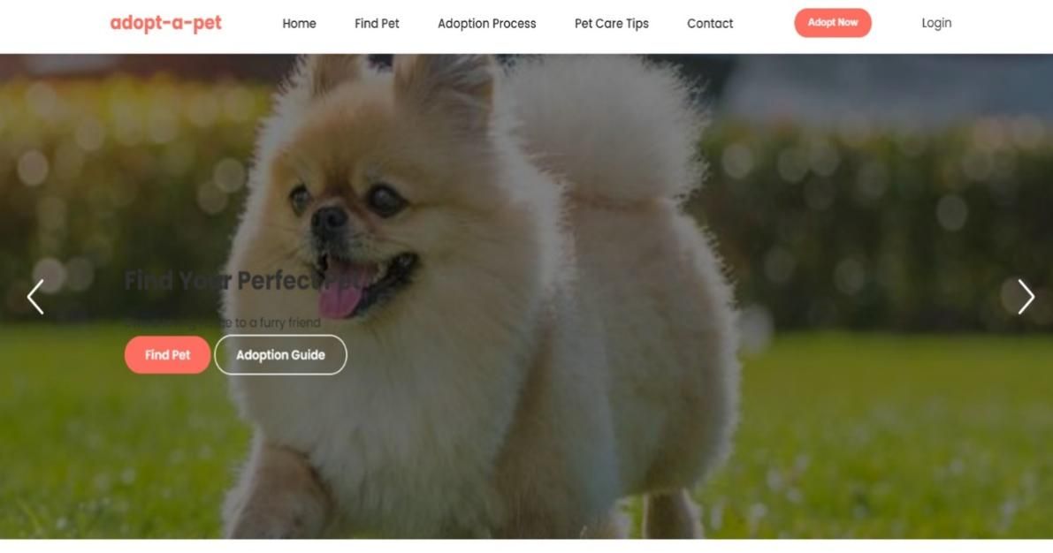**

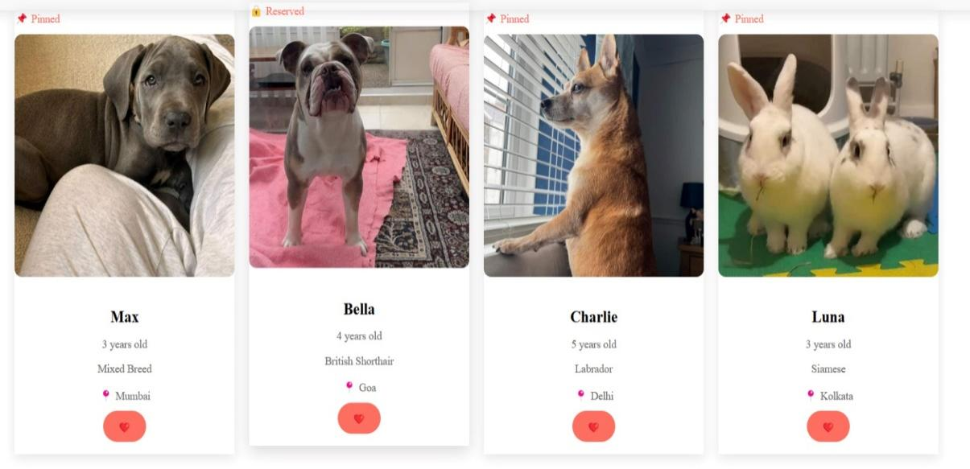

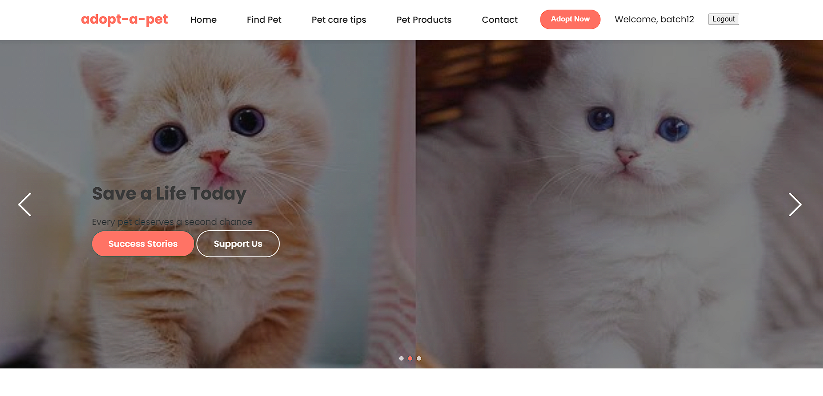

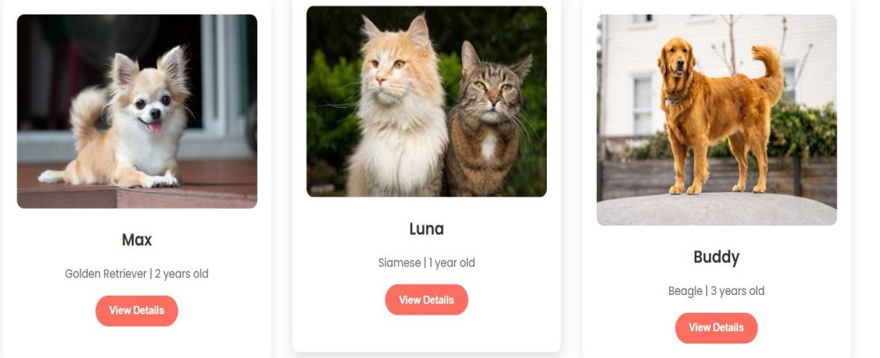

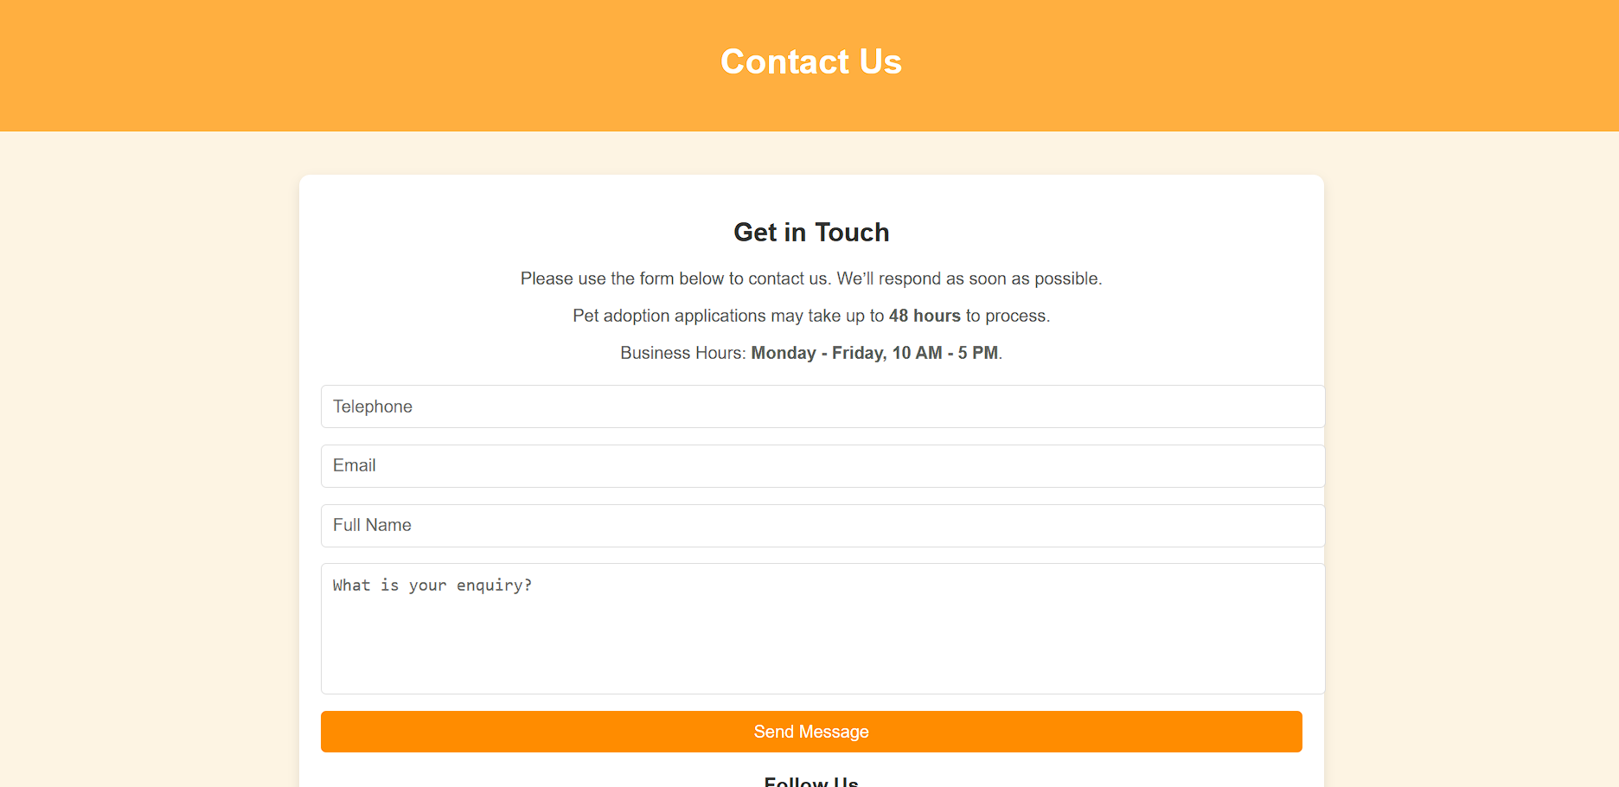

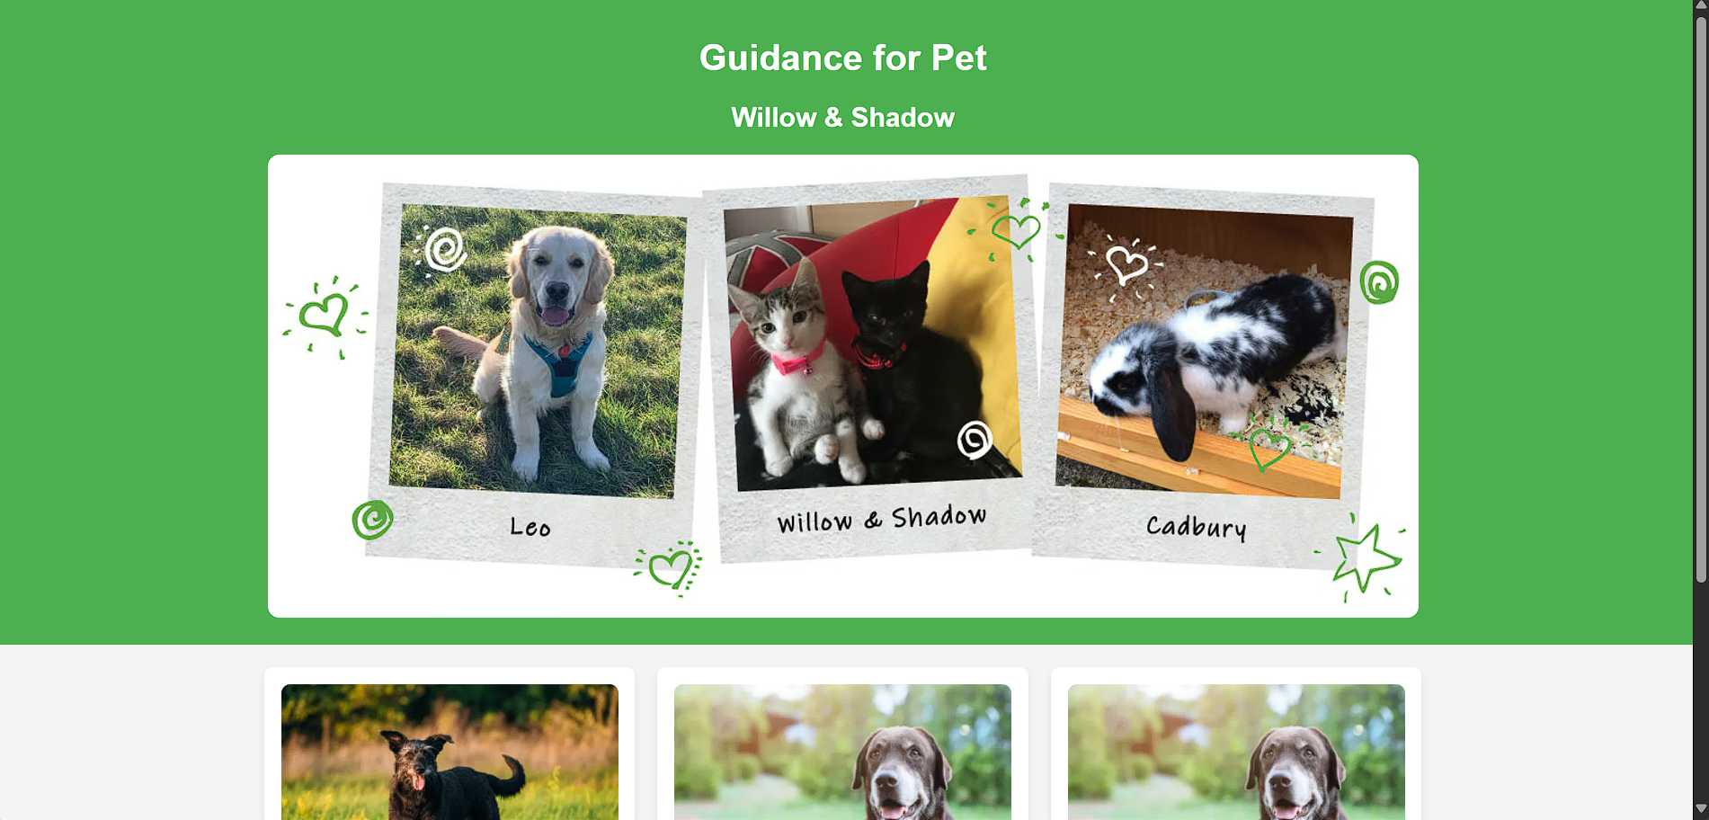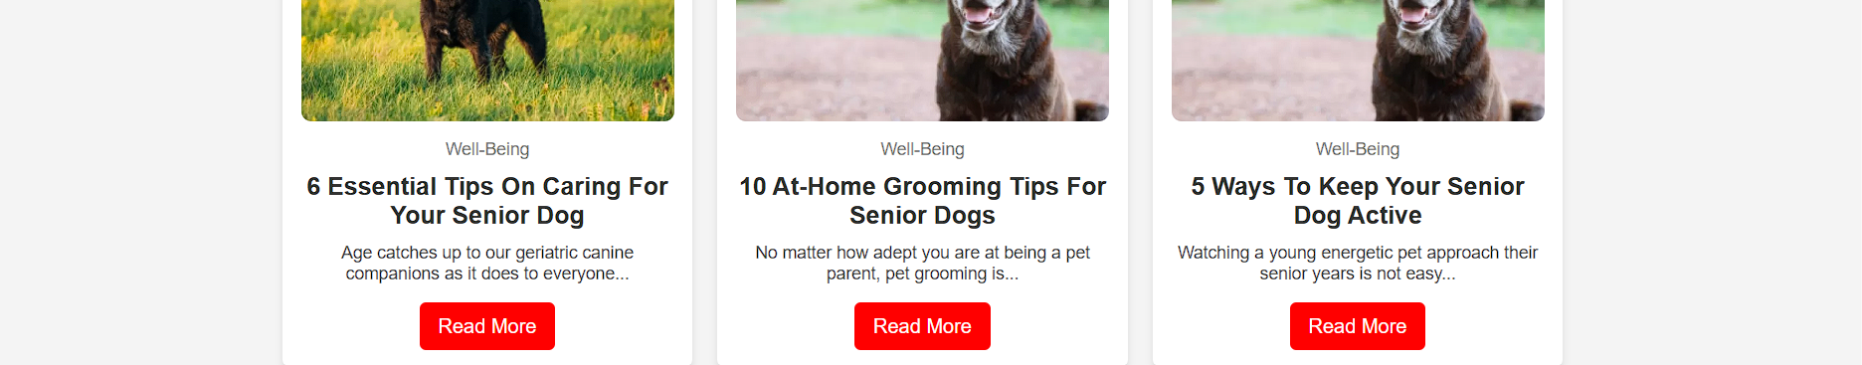

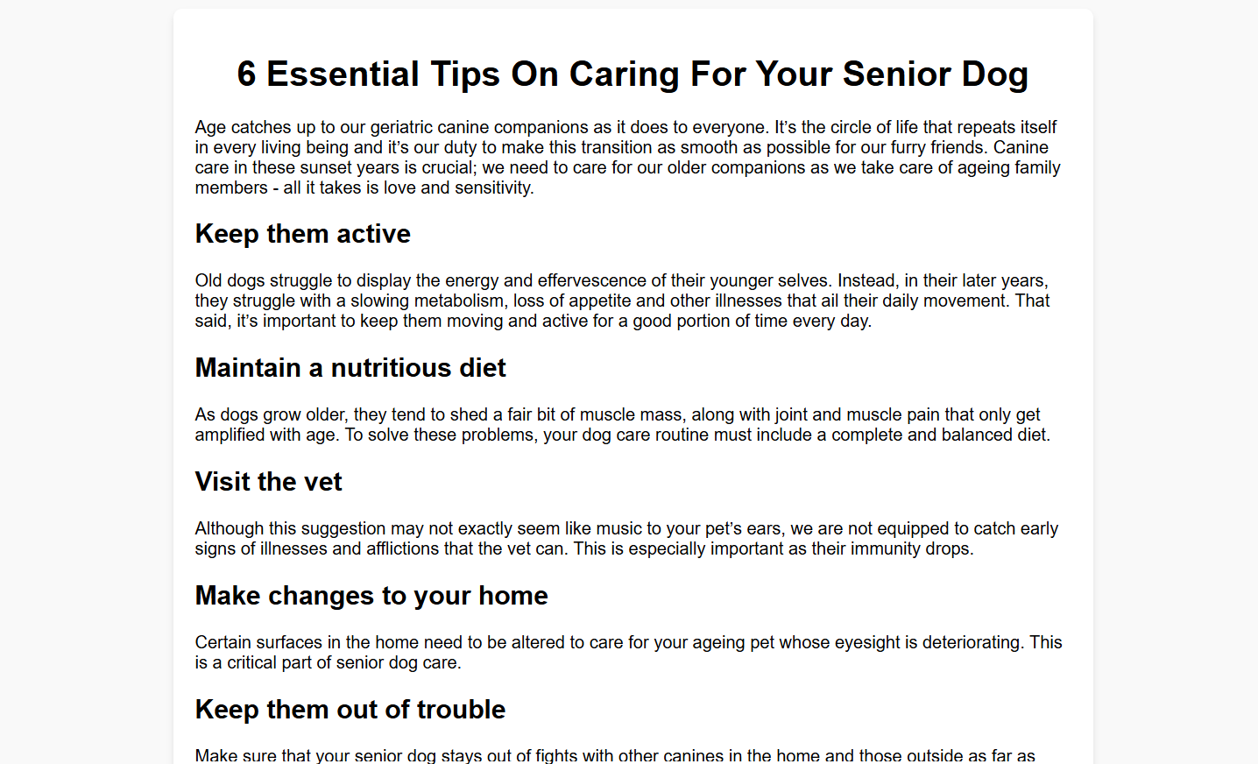

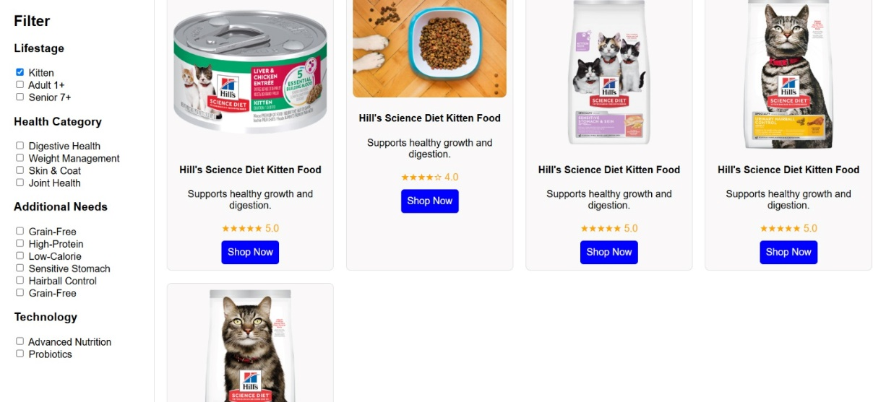



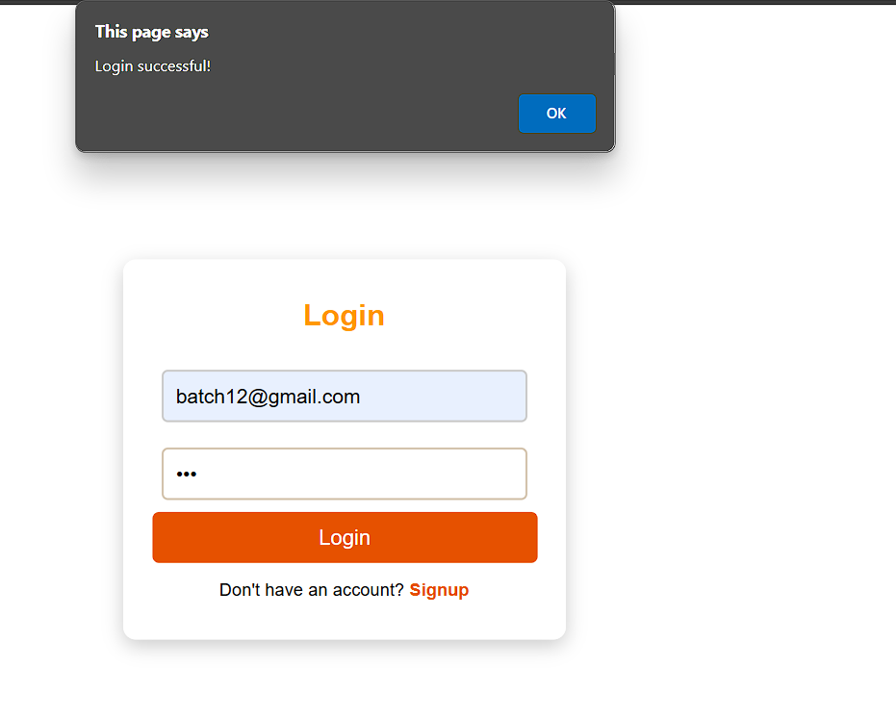

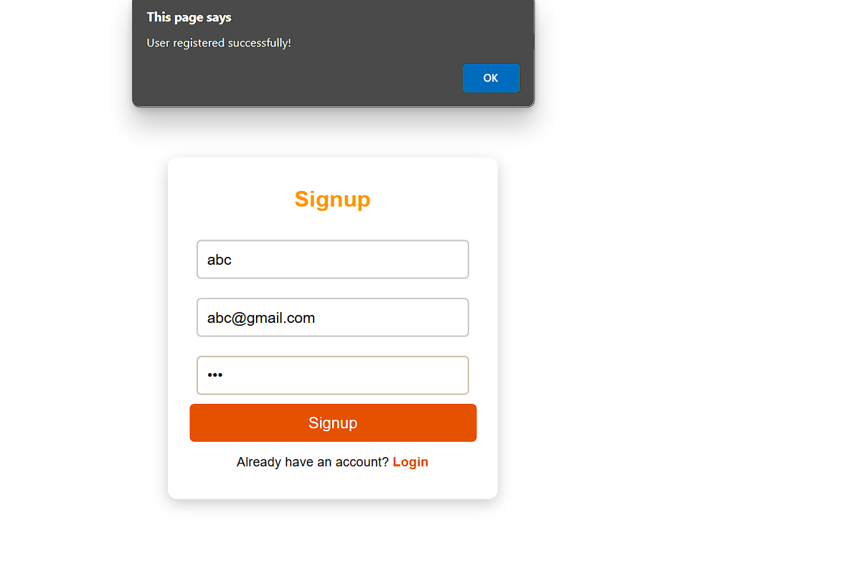

**6.CONCLUSION:**

The Street Pet Adoption Platform developed in this project provides a dedicated, user-friendly, and accessible digital solution to support the adoption and care of stray animals. Unlike commercial adoption websites, this platform focuses on **rescuing street pets**, providing **shelter**, and ensuring they are **vaccinated in collaboration with social organizations** before being placed for adoption.

The platform features include:

* Pet information display with images and details
* Simple and intuitive user interface for adopters
* Post-adoption care tips for responsible pet ownership

This initiative promotes **compassionate adoption** as a **service** rather than a business, helping reduce the number of homeless animals on the streets. With further integration of admin tools, tracking systems, and wider NGO participation, this platform can evolve into a **scalable and impactful social service tool** that ensures a safe and loving environment for rescued street pets.

**REFERENCES:**

* Research Articles on Stray Animal Welfare and Adoption
* Government and NGO Reports on Street Pet Rescue Programs
* Adopt-a-Pet (2023). Community-Based Pet Adoption Models. Retrieved from [www.adoptapet.com](https://www.adoptapet.com" \t "_new)
* XAMPP & PHP Manual for Local Web Hosting and Backend Integration
* HTML, CSS & JavaScript
* Visual assets and images sourced from open-access pet image repositories

**Github-Link:**

<https://venkat666d.github.io/pet-adaption1/>